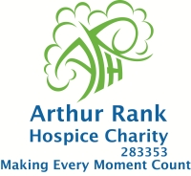

**The Lisa Barnes Memorial Fund**

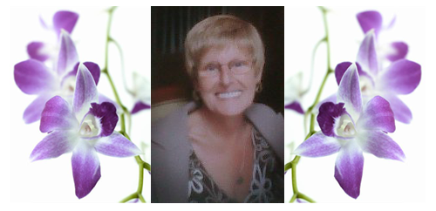

**In Aid of Arthur Rank Hospice**

**Charity**

**RACE NIGHT**

[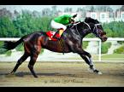](http://uk.wrs.yahoo.com/_ylt=A7x9QX4jelZNtCoAbxxLBQx.;_ylu=X3oDMTB1YzN1aGU2BHNlYwNzYwRjb2xvA2lyZAR2dGlkA1VLQzAwMV83Mg--/SIG=1pimlncrs/EXP=1297534595/**http:/uk.images.search.yahoo.com/images/view?back=http://uk.search.yahoo.com/search?ei=UTF-8&p=race+horses&w=500&h=375&imgurl=farm4.static.flickr.com/3471/3266198445_abcdfa7dfc.jpg&size=133.5kB&name=3266198445+abcdfa7dfc+jpg%0a++++&rcurl=http://www.flickr.com/photos/baderalbassam/3266198445/&rurl=http://www.flickr.com/photos/baderalbassam/3266198445/&p=race+horses&type=jpeg&no=2&tt=128,301&oid=b4e989657f5bbc7c&fusr=Bader+AL+Bassam&hurl=http://www.flickr.com/photos/baderalbassam/&tit=kuwait+horses+race++winner+horse+1&sigr=11mdbqube&sigi=11muhjqfo&sigb=11oqc4en0&sigh=11b97l6ge&fr=yfp-t-702)

FRIDAY 3rd.JUNE 2011

THE BROOK, BROOK ST SOHAM

Compare-MISS FELICITY FLAPPS

TICKET LINE: 01353656338

TICKETS £5 include cheese & biscuits